Queries optimisation:

-- Write a query to fetch the names of employees and their department name.

select e.first_name,d.department_name from employees e join departments d on e.department_id=d.department_id;

Before index:

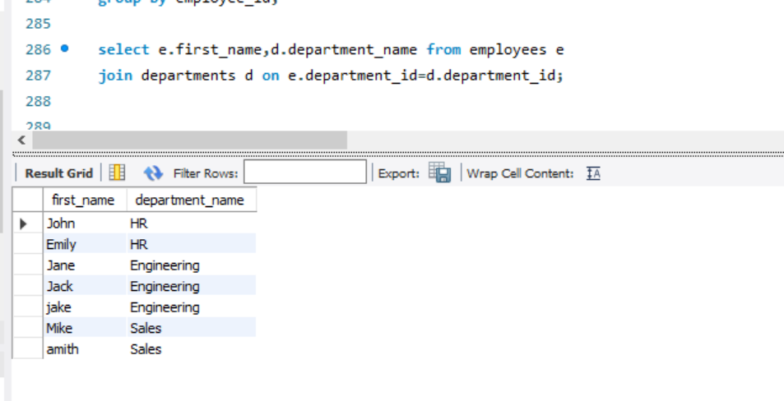

Before adding indexes explain

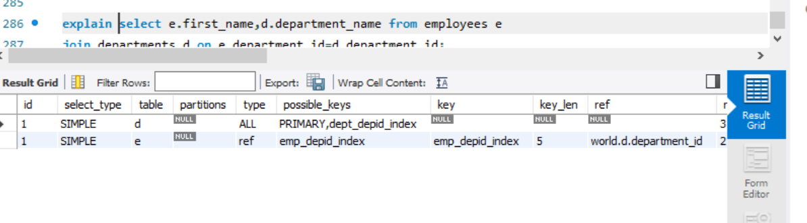

After index:

-- create index emp_depid_index on employees (department_id) -- create index dept_depid_index on departments (department_id)

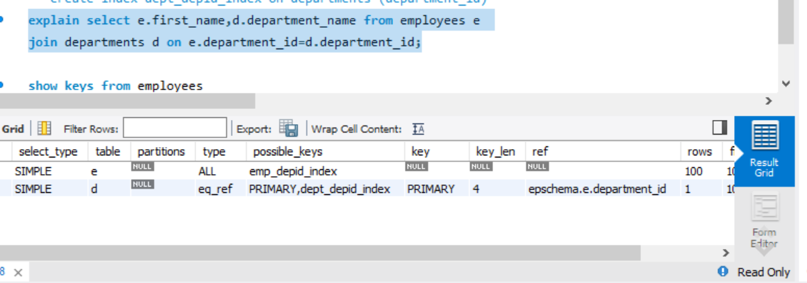

2)